registered charity # 1091201

**Portcullis House**

**Old Hakin Road**

**Merlin’s Bridge,**

**Haverfordwest**

**Pembrokeshire**

**SA61 1XE**

By and for adults with

learning disabilities

and/or autism

**Young Moving On**

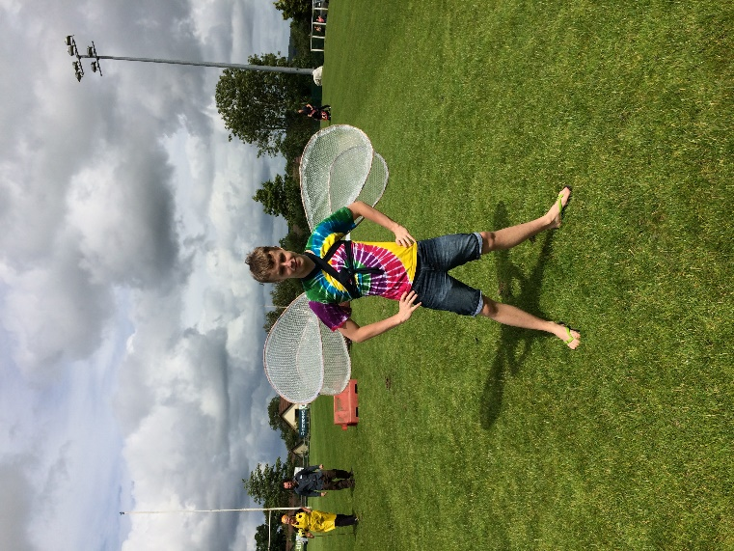

**Young Tudor Project is a social club for 13-18 year olds with autism &/or a learning disability**

**It is a safe space to make new friends and hang out**

**We do lots of fun projects**

**We eat together for free**

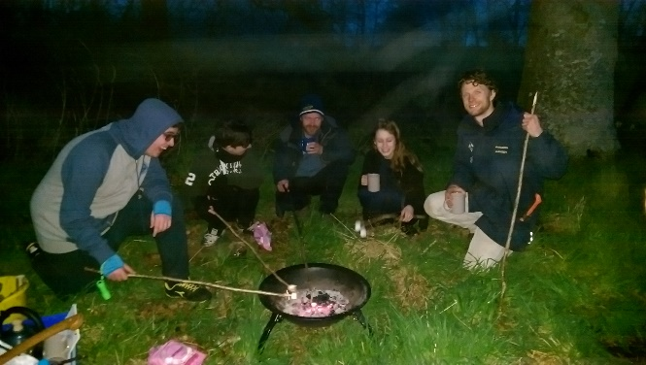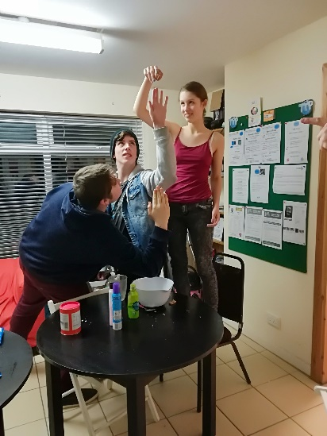

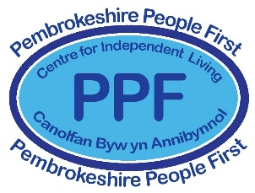

**Thursday evenings**

**5:00-7:00**

**The PPF office**

**Phone 01437 762524**

**Ask for Jon**

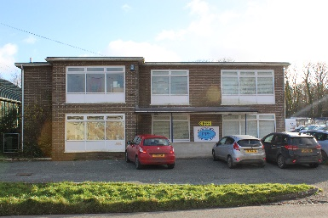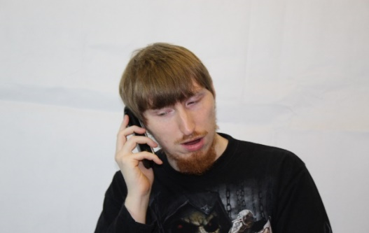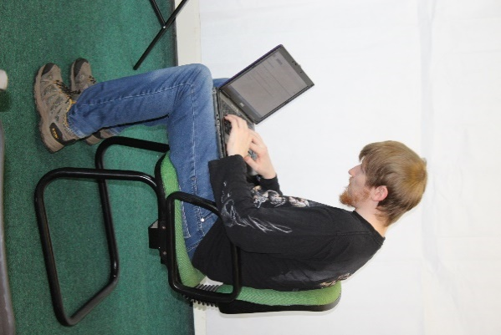

**jon@pembrokeshirepeople1st.org.uk**