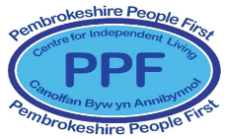
registered charity # 1091201
By and for adults with
learning disabilities
and/or autism
Portcullis House
Old Hakin Road
Merlin’s Bridge,
Haverfordwest
Pembrokeshire
SA61 1XE
Training

Pembrokeshire People First (PPF) are respected providers of training for the statutory and third sectors, and for private organisations. Our training is delivered by experienced trainers, in collaboration with our members, people with learning disabilities and/or Autism who have been trained in delivering workshops and courses, and who are powerful “experts by experience”.

PPF delivers participative, engaging training, and specialises in courses relating to human rights, awareness, values and attitudes, choices and decision making, and equality.

Our flagship training is a three day package, ideal for support workers, managers, staff induction, health professionals and anyone interested in developing understanding, knowledge and practical skills to support people with learning disabilities and/or Autism.

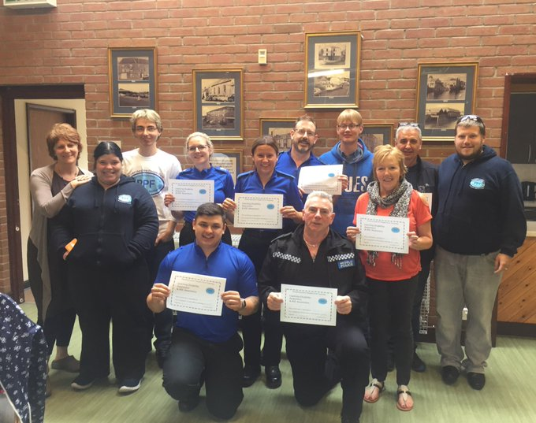

Learning Disability Awareness
This course is co-delivered by people with learning disabilities. Although it covers essential information, like the social vs medical model, what a learning disability is defined as, and what a hate crime is, its focus is on our members’ experience as adults with learning disabilities, why choice and respect are so important, and how you can support adults with learning disabilities to live full, meaningful lives in their communities.

Autism Awareness and Acceptance
This session has been written and is delivered exclusively by autistic members, and combines information about what Autism is (and isn’t) with lots of practical work around communication. All PPF staff have received this training and found it insightful and very useful.
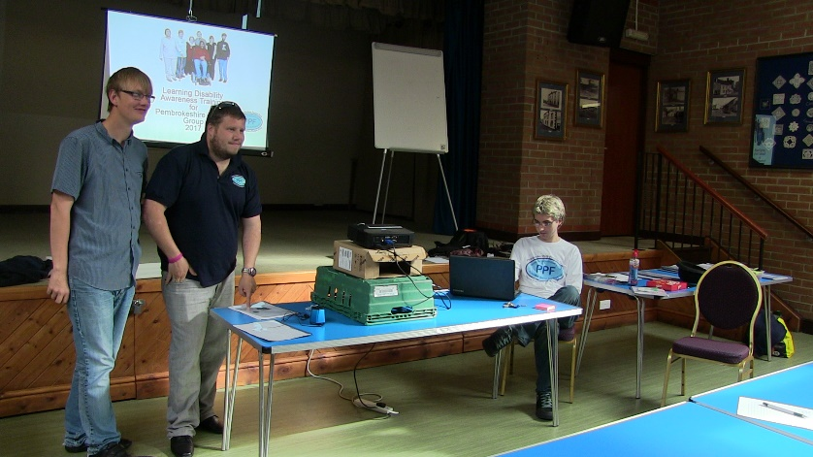

Values and Attitudes – and what capacity is really all about
A practice-centred participative workshop exploring the legal framework of choices and decision-making from a person-centred values perspective. The aim is to assist participants to feel more confident to support and advocate for the people they support in an effective way.

Equality, Diversity and Inclusion
This participative session provides an understanding of issues around equality, diversity and inclusion; explores values and attitudes; challenges ourselves and our practice; and looks at the legal framework and how it impacts on our work, asking key questions such as what diversity means; if we can truly be equal; what the barriers to equality are; and how we can challenge – ourselves and others – constructively.

Human Rights
This session is designed to give participants a greater understanding of the idea of human rights, where the concept came from, how it impacts us in our private and professional lives, and to challenge some myths. It will look at how the Human Rights Act applies to us in our work – and will be largely
discussion-based. Although the legal framework will be covered, this is a practical session, with resources for using the Act in participants’ work.

Advocacy in your work
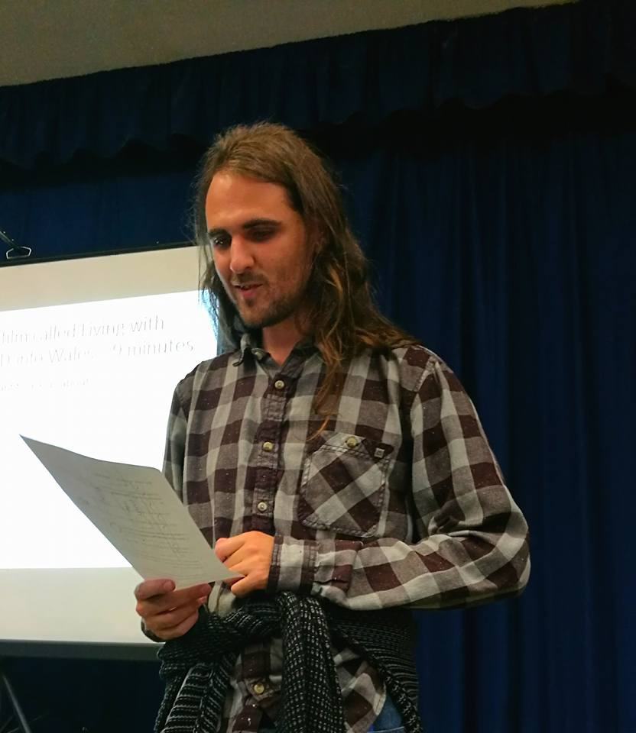
This session aims to de-bunk the idea that “only advocates advocate”, taking as its starting point the fact that all good support, whether paid for, family or community, uses advocacy tools to ensure that an individual’s voice is heard and respected. The session covers basic advocacy principles; different types of advocacy; the difference between advice and advocacy; and active listening and communication. It will also include discussions around how advocacy organizations and participants can best work together cooperatively, for the benefit of people with learning disabilities.

What does good support look like to us?
The final session in our programme is handed over to our member trainers, who are open to questions from participants, and will explain situations, positive and negative, that underline their experiences of support, of independence in their communities, and the difference it makes when they are at the centre
of their lives.

Training can be delivered in your premises or in our training suite, and can be arranged over three consecutive days or a longer period, as suits your organisation.

Tailor-made courses PPF can deliver on a wider range of subjects, and provide input into staff induction and CPD programmes. Please contact us to discuss your specific requirements.
We can also provide individual sessions from the above programme, and a wide range of workshops and courses for adults with learning disabilities, such as Keeping Yourself Safe, Relationships, and Using Social Media Safely.

What people have said after attending our training courses:

“I attended a seminar held at Haverfordwest Police Station earlier this year and it was amazing. You would have heard a pin drop during the session, and trust me holding a police officer’s attention for a length of time in a conference room is quite the challenge, so fair play to the guest speakers from Pembs People First!”
PCSO

“I'm a lecturer in a college in Glasgow and I just wanted to say thank you for your fantastic videos…... I have used them with a class who find it difficult to talk about the sad things that affect us all, and seeing your pictures has helped us understand that this is part of life, so when we're sad it’s OK to feel that way”.
Alison Young – testimonial around PPF’s wider work challenging conceptions

“Impacting and powerful. The best training I have attended”.
Delegate

“My staff and myself attended training Provided by PPF, the feedback from my staff team was amazing. We all enjoyed the training greatly and we all felt that we had learnt something from the sessions that we attended. We all took something different from the training, which helped us as a team to reflect on what we can improve on. I feel it helped my team to be more mindful of people’s individuality and has enabled them to put what they learnt in the training to practise in their everyday work. Fantastic training delivered by enthusiastic and knowledgeable people…thank you”.
Manager, support service

“I have learned so much about learning disability. Your trainers are fab!”
Support worker

To discuss your training needs, please contact us:

Email karen@pembrokeshirepeople1st.org.uk

Phone the office on 01437 762524 and ask to speak to Karen

