registered charity # 1091201

**Portcullis House**

**Old Hakin Road**

**Merlin’s Bridge,**

**Haverfordwest**

**Pembrokeshire**

**SA61 1XE**

By and for adults with

learning disabilities

and/or autism

**Moving On**

**Moving On is a safe space for you to learn lots of skills to help you live more independently**

**Some of the things we can help you with are:**

• **Cooking and healthy eating**

• **How to have healthy relationships**

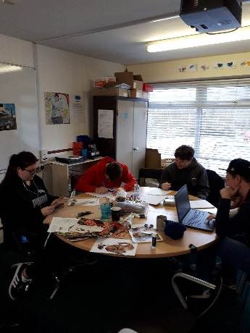

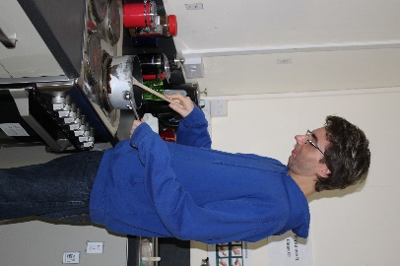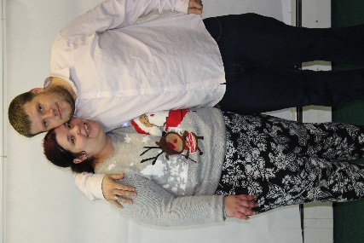

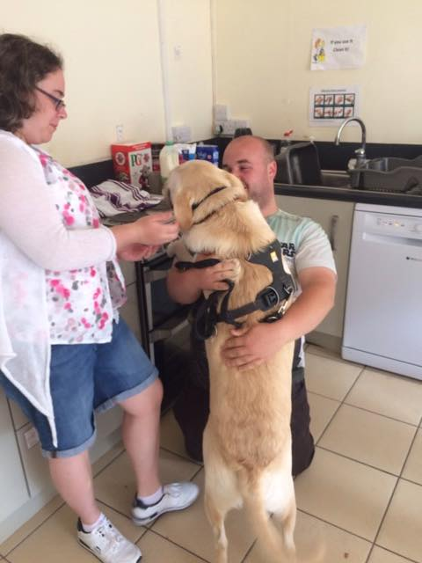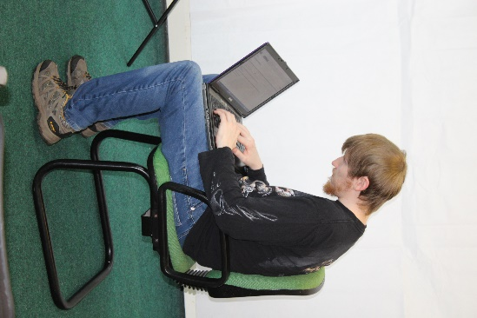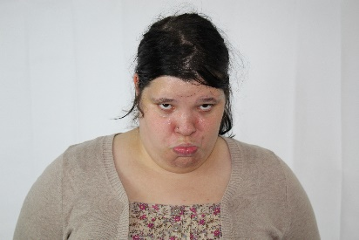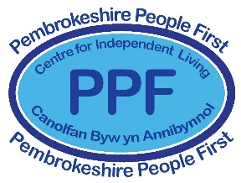

• **Learn different ways to relax**

• **Travel training**

• **What to do when you are worried or sad**

• **Internet safety**

**Interested?**

**Speak with your social worker who will refer you**

**Or call Matt on 01437 769135**