registered charity # 1091201

**Portcullis House**

**Old Hakin Road**

**Merlin’s Bridge,**

**Haverfordwest**

**Pembrokeshire**

**SA61 1XE**

By and for adults with

learning disabilities

and/or autism

**Gaming Club**

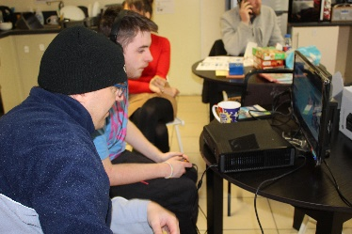

**A group for people who enjoy video games**

**We have a PS4 you can play on a big screen**

**We have a PS2, Xbox 360 and Wii**

**We video and edit game reviews and put them on YouTube**

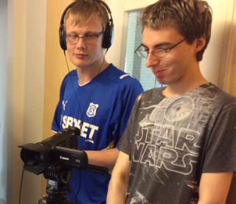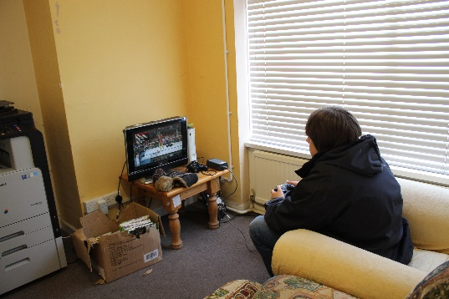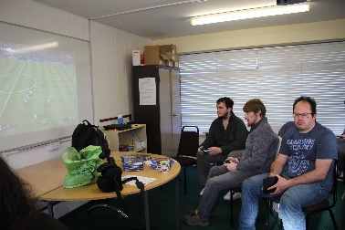

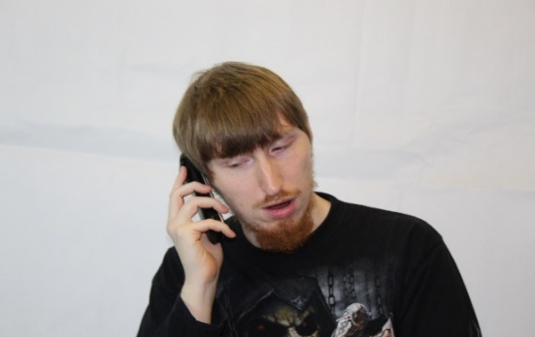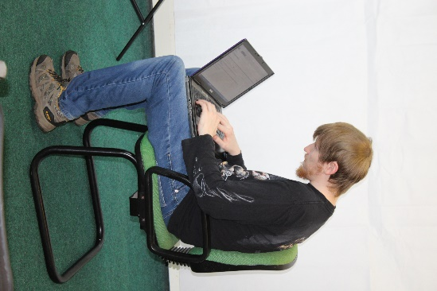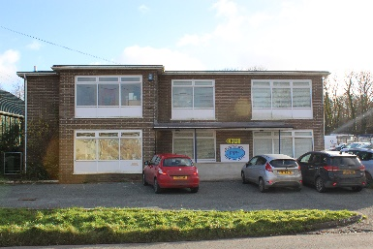

**jon@pembrokeshirepeople1st.org.uk**

**Every other Friday**

**10:00-12:00**

**PPF Office**

**Phone 01437 762524**

**Ask for Jon**